CTF Write-up: Timeline 1 (Forensics)

Overview
This challenge involves the forensic analysis of a disk image to recover a hidden flag. The objective is to utilize SleuthKit to reconstruct historical file system activities and identify evidence of unauthorized or suspicious user behavior.
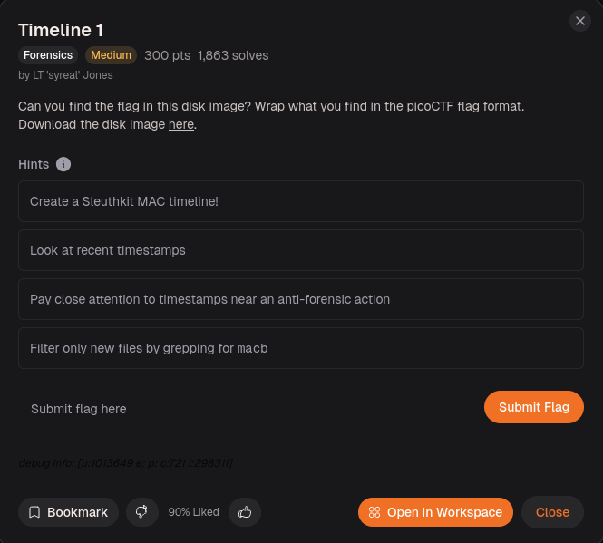
From the hint given it is said to create a MAC timeline. Afterwards to focus and pay close attention to the timestamps. Lastly to filter “macb”

Description
The challenge presents a compressed disk image that requires careful investigation to locate a specific hidden artifact. The final extracted data must be formatted according to the picoCTF flag structure to be accepted.

Strategy
Timeline Creation: The hint to create a SleuthKit MAC timeline was the primary directive for tracking file system modifications over time.
Temporal Correlation: The hint to analyze timestamps near an "anti-forensic" action guided me to look for suspicious activity immediately preceding the system shutdown.
Data Filtering: The hint to use grep for filtering specific metadata was essential for isolating relevant artifacts from the extensive log data

Solving Steps
My methodology focused on establishing a controlled environment for evidence, followed by a targeted, hypothesis-driven search of system configuration paths.

Decompression
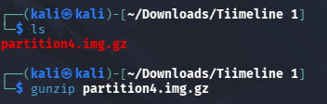
first decompressed the disk image (partition4.img.gz) to extract the raw binary data, which is a prerequisite for file system parsing.

Timeline Analysis

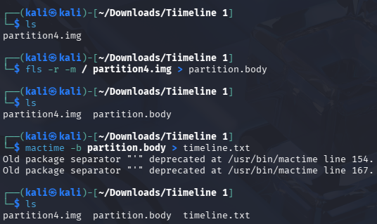
I executed fls to enumerate files and mactime to construct a chronological metadata timeline. This transformed raw file system data into an indexed, human-readable format.



Searching
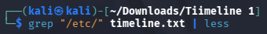
Rather than an unstructured search, I performed a directory-level sweep of /etc/. Configuration directories are high-priority forensic targets for identifying persistence or tampered services. This revealed Inode 32716 as a significant outlier.

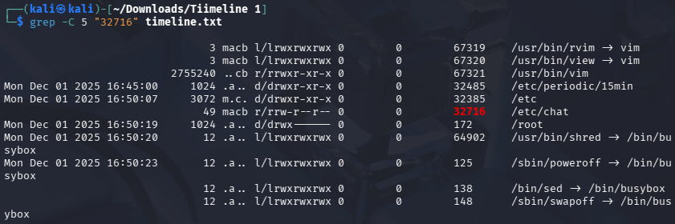
To confirm the relevance of Inode 32716, I utilized grep -C 5 to view the activity window. The file access occurred at 16:50:07, only 16 seconds prior to the poweroff command, strongly indicating an intentional anti-forensic attempt.

Extraction

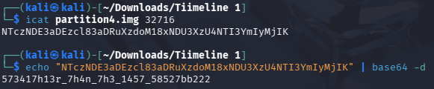
I extracted the artifact using icat and identified it as Base64 encoded. I then decoded the content to reveal the final flag.

Flag
Final Flag : picoCTF{573417h13r_7h4n_7h3_1457_58527bb222}

